Collective Worship At All Saints Upton CE Primary School
2025 – 2026
3rd September 2025 – 3rd October 2025  (4 Wks 3 Days) |     Compassion  Love
6th October 2025 – 10th October 2025  (1 Wk) |     Black History Week
13th October 2025 – 21st November 2025  (3 Wks 4 Days) |     Thankfulness
10th November 2025 – 14th November 2025  (1 Wk) |     Anti-bullying Week
24th November 2025 - 19th December 2025  (4 Wks) |     Advent
5th January 2026– 30th January 2026  (4 Wks) |     Forgiveness
2nd February 2026– 27th February 2026  (3 Wks) |     Hope
2nd March 2026 – 27th March 2026  (4 Wks) |   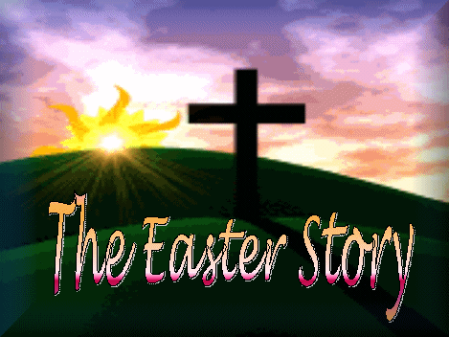  Easter
13th April 2026 – 15th May 2026  (4 Wks 4 Days) Inc SATS Week |     Perseverance
18th May 2026– 19th June 2026  (3 Wks 4 Days) |     Trust
22nd June 2026 – 17th July 2026  (4 Wks) |     Peace

