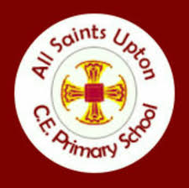

All saints upton church of england primary school
Science Development Strategy – Year 6 Key Skills
Ear
Topics to be covered by the End of Year 6:

Living things and their habitats

Sort and group animals based on their features, using examples as a guide.
Describe Carl Linnaeus and his development of his classification system.
Place animals into given groups based on certain characteristics.
Design a creature with a specific set of characteristics, using prompts and a word grid.
Name types of microorganism.
Set up an investigation into harmful microorganisms.
Design a microorganism using given characteristics.
Complete descriptions on the characteristics of groups of organisms, using images as prompts.

Animals including Humans

Identify the main parts of the circulatory system.
Explain the main functions of the heart, lungs and blood vessels in the circulatory system.
State how the digestive system breaks down nutrients.
Explain what constitutes a healthy lifestyle.
Describe how drugs and alcohol can impact negatively on the body.

Evolution and Inheritance

Identify inherited traits and adaptive traits.
Understand that adaptations are random mutations.
Examine fossil evidence supporting the idea of evolution.
Identify the difference between selective and cross-breeding.

Light

Recognise that light travels in straight lines.
Describe how light enables us to see.
Understand reflection as light bouncing off a surface.
Identify some effects of refraction.
Identify the visible spectrum.
Explore colours using light.
Recognise that Isaac Newton discovered information about light and colour.
Explain that objects block light to form shadows.

Working Scientifically

Predict what will happen in an investigation.
Be able to plan and conduct an investigation.
Plan an investigation based on the results of a previous investigation.
Decide how to record data.
Make observations.
Take accurate measurements.
Record results.

